|  |  |
| --- | --- |
| **Database Design Document** | |
| **Project Name:** | **FINALyze – Business Financial Analyzer** |
| **Description:** | The web application calculates the Gross margin, Net margin and ROI for products.  This app provides insight into products Finance health and helps in Analysing its investment decision. |
| **Deadline:** | 29th March 2025 |
| **Student Name:** | Mohammed Aiman Khan |

**Data System Overview:**

This overview section contains a list of each table and their relationships with each other – brief and general.

The FINALyzer’s data management system contains three components. They are the AUTHENTICATION, MASTER and TRANSCATIONAL entry System, CALCULLATION and REPORTING System.

**ER DIAGRAM**

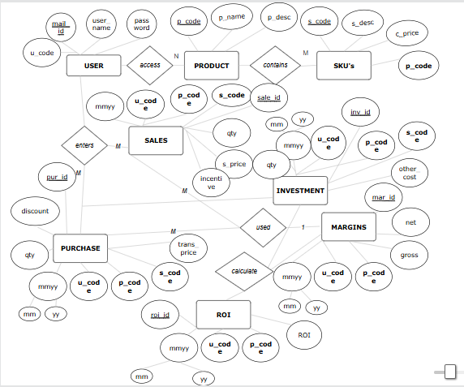

**AUTHENTICATION data tables**

**Data Table -** These tables contain the user data.

| **USER** | | | |
| --- | --- | --- | --- |
| **User-id** | **User-name** | **Mail id** | **password** |
| Primary key |  | Unique key |  |
| 1 | Aiman | [aiman@123.com](mailto:aiman@123.com) | welcome12345 |
| User id | Name | Email | password |

**MASTER data tables**

**Data Table -** These tables contain the master data for PRODUCTS and SKUS

| **PRODUCT** | | |
| --- | --- | --- |
| **P_code** | **P_name** | **P_desc** |
| Primary key |  |  |
| P001 | Wheat | [grain](mailto:aiman@123.com) most in demand |
| Product code | Product name | description |

| **SKU** | | | |
| --- | --- | --- | --- |
| **S_code** | **S_desc** | **P_code** | **C_price** |
| Primary key |  | Foreign Key |  |
| S001 | 100 kg bag of wheat | P001 | 5000 |
| Sku code | Description | Product | Cost price |

**TRANSACTION data tables**

**Data Table -** These tables contain the monthly transactional data for SALE,PURCHASE and INVESTMENT

|  | **SALES** | | | | | | |
| --- | --- | --- | --- | --- | --- | --- | --- |
| **Sal_id** | **Mmyy** | **U_code** | **P_code** | **S_code** | **Qty** | **S_price** | **incentive** |
| Primary Key | Foreign key | | | |  |  |  |
| 1 | 0225 | 1 | P001 | S001 | 100 | 6000 | 100 |
|  | Year month | Logged in user | Product | Sku | Quantity | Sale price | incentive |

|  | **PURCHASES** | | | | | | |
| --- | --- | --- | --- | --- | --- | --- | --- |
| **Pur_id** | **Mmyy** | **U_code** | **P_code** | **S_code** | **Qty** | **Trans_cost** | **discount** |
| Primary Key | Foreign key | | | |  |  |  |
| 1 | 0225 | 1 | P001 | S001 | 100 | 6000 | 100 |
|  | Year month | Logged in user | Product | Sku | Quantity | Transportation cost | discount |

|  | **INVESTMENT** | | | | | |
| --- | --- | --- | --- | --- | --- | --- |
| **Inv_id** | **Mmyy** | **U_code** | **P_code** | **S_code** | **Qty** | **Other_cost** |
| Primary Key | Foreign key | | | |  |  |
| 1 | 0225 | 1 | P001 | S001 | 20 | 800 |
|  | Year month | Logged in user | Product | Sku | Quantity in market | Other cost |

**CACULLATION tables**

**Data Table -** These tables contain the calculated data for easy of reporting

|  | **MARGINS** | | | | | |
| --- | --- | --- | --- | --- | --- | --- |
| **Mar_id** | **Mmyy** | **U_code** | **P_code** | **S_code** | **G_margin** | **N_margin** |
| Primary Key | Foreign key | | | |  |  |
| 1 | 0225 | 1 | P001 | S001 | 7000 | 5500 |
|  | Year month | Logged in user | Product | Sku | Gross Margin | Net Margin |

|  | **ROI** | | | | |
| --- | --- | --- | --- | --- | --- |
| **Roi_id** | **Mmyy** | **U_code** | **P_code** | **S_code** | **ROI** |
| Primary Key | Foreign key | | | |  |
| 1 | 0225 | 1 | P001 | S001 | 7000 |
|  | Year month | Logged in user | Product | Sku | Return on Investment |